INTRODUCTION
Weather is what is happening in the atmosphere at any time or short period of time. Weather conditions can change suddenly. Today may be warm and sunny, tomorrow may be cool and cloudy. Weather conditions include clouds, rain, snow, sleet, hail, fog, mist, sunshine, wind, temperature and thunderstorms. Weather forecasting is the application of science and technology to predict the conditions of the atmosphere for a given location and time. Weather forecasts are made by collecting quantitative data about the current state of the atmosphere at a given place and using meteorology to project how the atmosphere will change. The role of Technology has been remarkable in the field of weather forecasting. Weather data is not only necessary for researchers or scientists, ordinary people can be benefitted from it as well. People nowadays are feeling the necessity of weather data as well. There are a variety of weather mobile apps in Google Play and the App store. Those apps have great features and functionalities to satisfy users. However, only a few of them have friendly user interface and human centered interactions, which means that a lot of them might be difficult to be navigated even though they provide enough functionalities. It is not convenient for new users. Therefore, we would like to do improvements on weather mobile apps.

About the project
The weather API works over the bases of abstracting API keys, creating the application and installing packages, building city search component, Fetching and mapping data from weather API and building weather forecast component.
The approach to get the weather updates is as follows:
- We make Open weather 3.0 API call to receive all essential weather data in one response.
- Access current weather data for any location including over 200,000 cities.
- The API collect and process weather data from different sources such as global and local weather models, satellites, radars and a vast network of weather stations
- At first the application requires the location of the user. This can be entered manually or can be read by the application if provided with the location access.
- This is sent as an API call to retrieve all the weather data in one response.
- The data from cloud can be retrieved to JSON, XML, and HTML formats.
- The obtained information from the API response is sorted out at the client side and represented based on the application.

  - Objective
Our objective of the project is to make sure to provide the end users with accurate weather forecast. This project demonstrates the use of API to obtain weather information to forecast weather. This is done to increase its accuracy and usefulness improve performance. While much has been accomplished in improving weather forecasts, there remains much room for improvement. The forecasting community is working closely with multiple stakeholders to ensure that forecasts and warnings meet their specific needs. Simultaneously, they are developing new technologies and observational networks that can enhance forecaster skill and the value of their services to their users.

2.System Analysis

2.1 Existing System
- We make API call to receive weather data.
- Access current weather data for specified locations.
- The API collect and process weather data from sources such as local weather models.
- Get all the warnings from national weather agencies.
- Data feed provides all active weather alerts from the entire world and each alert contents date and location.
- The data from cloud can be retrieved to JSON, XML formats

2.2 Proposed System

2.2.1 Details
- We make Open weather 3.0 API call to receive all essential weather data in one response.
- Access current weather data for any location including over 200,000 cities.
- The API collect and process weather data from different sources such as global and local weather models, satellites, radars and a vast network of weather stations
- Get all the warnings from national weather agencies and these alerts are pushed to your endpoint as soon as they occur.
- Data feed provides all active weather alerts from the entire world and each alert contents date, time, location, and detailed description
- The data from cloud can be retrieved to JSON, XML, and HTML formats.

2.2.2 Impact on Environment

In the post-pandemic world, people care far more about health and the environmental impact on it. As a result, consumer demand for effective wellness tools that empower actionable decision-making has exploded. As environmental reporting methods improve and an increased emphasis gets placed on the impact of environmental exposure on person’s wellbeing, personalized health-focused environmental insights have become a hot commodity.

2.2.3 Safety
Weather forecasting app using API is a secured application where the data provided by the users is kept safe with us. We constantly monitor and work towards closing any threats that might put it at any risk. Our application will not display any disturbing advertisements or pop ups.

2.2.4 Ethics
We have followed the general SW ethics like securing privacy information of the resources using application, not harming anybody physically or virtually and maintaining confidentiality.

2.2.5 Cost

Since the project mainly involves coding and implementing it as an application, this project is economically feasible to implement. Also, all the resources used are open source, available easily on the internet. It is cost effective.

2.2.6 Type
Ours is an application which can be used when the user has an internet connection. This is a web application created using java Script, html, css and API.

2.2.7 Standards
Software processes can deal with many challenges facing the web development process. These challenges include volatility of requirements, strong user involvement, development time tightness, process simplicity, and production of valuable software at low cost. Weather forecast app using API was created using water fall model.
Waterfall approach was first SDLC Model to be used widely in Software Engineering to ensure success of the project. In "The Waterfall" approach, the whole process of software development is divided into separate phases. In this Waterfall model, typically, the outcome of one phase acts as the input for the next phase sequentially. The following illustration is a representation of the different phases of the Waterfall Model.

SDLC Waterfall Model
The sequential phases in Waterfall model are –
Requirement Gathering and analysis
All possible requirements of the system to be developed are captured in this phase and documented in a requirement specification document.
System Design
The requirement specifications from first phase are studied in this phase and the system design is prepared. This system design helps in specifying hardware and system requirements and helps in defining the overall system architecture.
Implementation
With inputs from the system design, the system is first developed in small programs called units, which are integrated in the next phase. Each unit is developed and tested for its functionality, which is referred to as Unit Testing.
Integration and Testing
All the units developed in the implementation phase are integrated into a system after testing of each unit. Post integration the entire system is tested for any faults and failures. Deployment of system Once the functional and non-functional testing is done; the product is deployed in the customer environment or released into the market.
Maintenance
There are some issues which come up in the client environment. To fix those issues, patches are released. Also, to enhance the product some better versions are released. Maintenance is done to deliver these changes in the customer environment. All these phases are cascaded to each other in which progress is seen as flowing steadily downwards (like a waterfall) through the phases. The next phase is started only after the defined set of goals are achieved for previous phase and it is signed off, so the name "Waterfall Model". In this model, phases do not overlap.
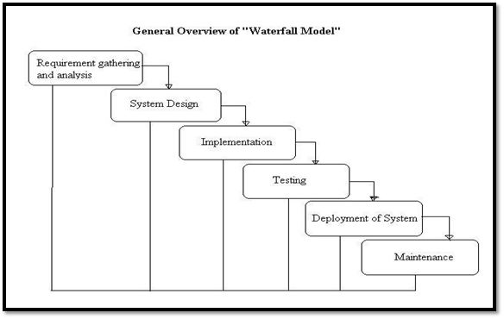
Figure (2.2.7): Waterfall model

2.3 Scope of the project
- The proposed system can be further optimized to provide accurate weather optics. This module can be deployed in various cloud operating systems and web applications.
- Various fields can implement our prospect to provide discussed parameters.
- By specify your route you’ll get weather data and national alerts for the point of destination and along the route, current forecasted and historical weather data for your route will also be provided.

2.4 Modules Description
There are three modules in our project. They are listed below with detailed descriptions.
- Input Module
- Processing Module
- Output Module
Input Module: Takes the location of the user.
Processing Module: Makes an API call to obtain weather details of that location.
Output module: Displays the weather details of the location.

2.5 System configuration

Software Requirements
- IDE : VisualStudio code
- API: OpenWeather
- Libraries : JavaScript Libraries
- Tools: boxIcons
- Operating System: Windows 7 or above

Hardware Requirements
- Processor: Pentium-III (or) Higher
- Ram: 64MB (or) Higher
- Cache: 512MB
- Hard disk: 250GB

Literature Overview

Literature survey is the most important step in software development process. Before developing the tool, it is necessary to determine the time factor, economy and company strength. Once these things are satisfied, ten next steps are to determine which operating system and language can be used for developing the tool. Once the programmers start building the tool the programmers need lot of external support. This support can be obtained from senior programmers, from book or from websites. Before building the system, the above consideration is taken into account for developing the proposed system.
JAVA SCRIPT
Javascript is a client-side language, which technically makes it a front-end language. But with the Node.js framework, JavaScript can also be used in back-end. Using JavaScript across the whole stack, for both front-end and back-end, is an excellent practice because it creates a cohesive application. When as much code as possible is all in the same language, it makes it easier to maintain, manage, update, and build with a single team.

HTML

HTML stands for HyperText Markup Language. It is used to design web pages using the markup language. HTML is the combination of Hypertext and Markup language. Hypertext defines the link between the web pages and markup language defines the text document within the tag that define the structure of web pages. HTML is used to create the structure of web pages that are displayed on the World Wide Web (www). It contains Tags and Attributes that are used to design the web pages. Also, we can link multiple pages using Hyperlinks.

CSS
CSS (Cascading Style Sheets) is used to apply styles to web pages. Cascading Style Sheets are fondly referred to as CSS. It is used to make web pages presentable. The reason for using this is to simplify the process of making web pages presentable. It allows you to apply styles on web pages. More importantly, it enables you to do this independently of the HTML that makes up each web page.

VS Code
Visual Studio Code is a lightweight but powerful source code editor which runs on your desktop and is available for Windows, macOS and Linux. It comes with built-in support for JavaScript, TypeScript and Node.js and has a rich ecosystem of extensions for other languages and runtimes (such as C++, C#, Java, Python, PHP, Go, .NET).

4. System Design

4.1 System Architecture
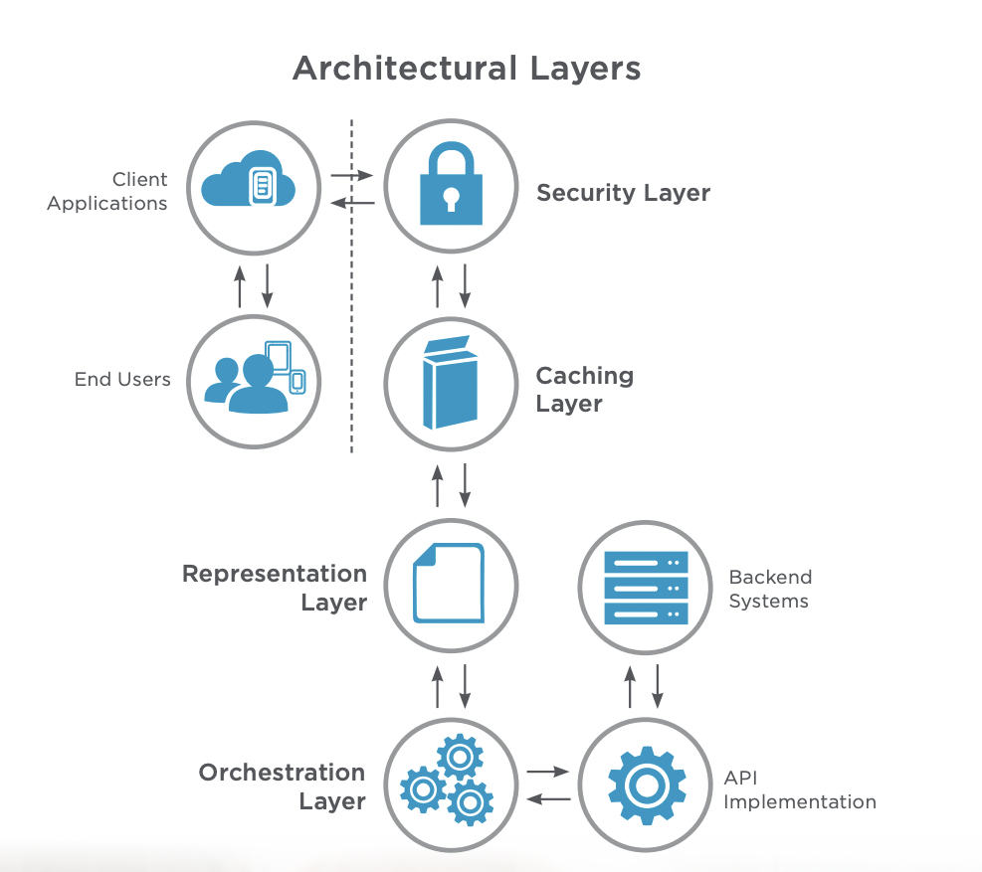
Figure (4.1): Architectural layers
4.2 UML Diagrams
4.2.1. Class Diagram
A class diagram in the Unified Modeling Language (UML) is a type of static structure diagram that describes the structure of a system by showing the system's classes, their attributes, operations (or methods), and the relationships among objects.

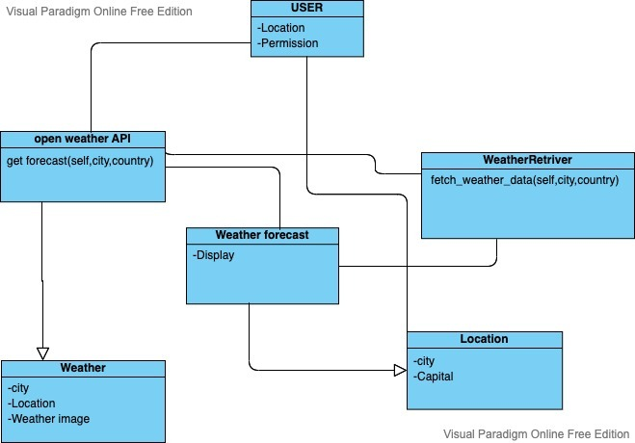
Figure (4.2.1): Class Diagram

Sequence Diagram
A sequence diagram simply depicts the interaction between objects in a sequential order i.e., the order in which these interactions take place. We can also use the terms event diagrams or event scenarios to refer to a sequence diagram. Sequence diagrams describe how and in what order the objects in a system function.

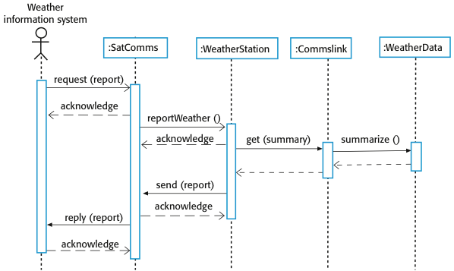
Figure (4.2.2): Sequence Diagram

4.2.3 Use Case Diagram
A use case diagram is a dynamic or behavior diagram in UML. Use case diagrams model the functionality of a system using actors and use cases. Use cases are a set of actions, services, and functions that the system needs to perform
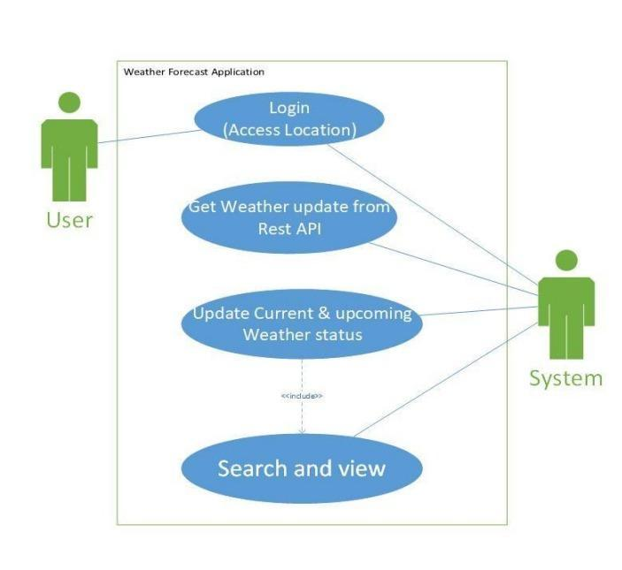
Figure (4.2.3): Use case diagram

4.2.4 UI diagram

The user interface diagram is an extended diagram type that provides a set of wire framing toolboxes with a rich palette of user interface elements for android and apple devices, as well as for web pages and dialogs. It is where you build out the visual structure of your application. It doesn’t let you choose colors, fonts or anything too specific instead it lets you set the high-level order and structure of the content on the page.
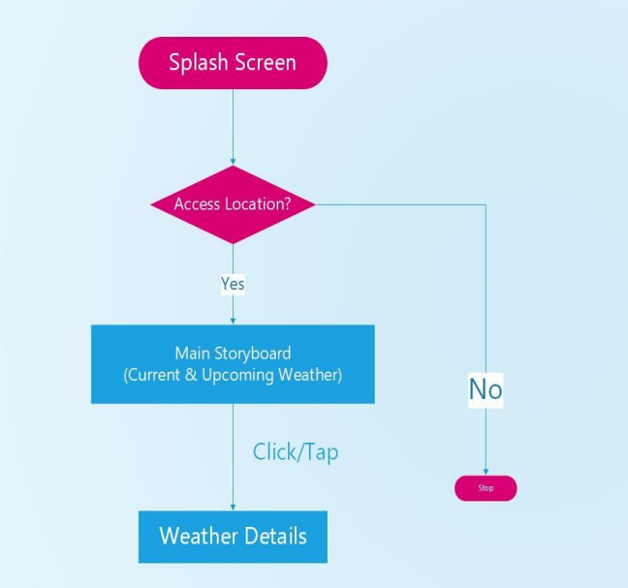
Figure (4.2.4): UI diagram

4.2.5 SYSTEM DIAGRAM
A system diagram is a simple and very high-level description of a system that exists or needs to be built. It is a simple diagram that can be drawn collaboratively in little time. It can help a team get a clear, complete, and common understanding of a system. Identifying and describing all the components of a System Diagram should enable a team to get a good understanding of the system. If the diagram is too complex, perhaps it needs to be broken down into multiple integrated systems.
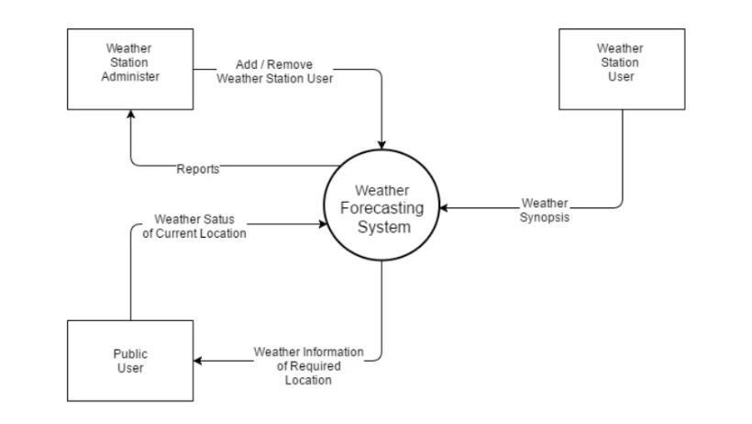
Figure (4.2.5): System diagram

4.3 System Design
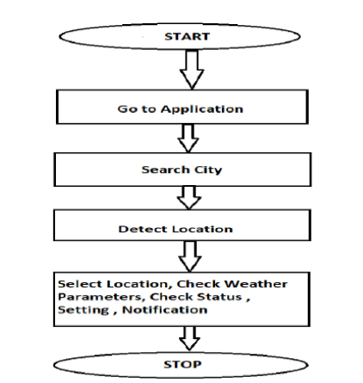
Figure (4.3): System Design Flowchart

5. Sample Code
Script.js

const wrapper = document.querySelector(".wrapper"),
inputPart = document.querySelector(".input-part"),
infoTxt = inputPart.querySelector(".info-txt"),
inputField = inputPart.querySelector("input"),
locationBtn = inputPart.querySelector("button"),
weatherPart = wrapper.querySelector(".weather-part"),
wIcon = weatherPart.querySelector("img"),
arrowBack = wrapper.querySelector("header i");

let api;

inputField.addEventListener("keyup", e =>{
if(e.key == "Enter" && inputField.value != ""){
requestApi(inputField.value);
}
});

locationBtn.addEventListener("click", () =>{
if(navigator.geolocation){
navigator.geolocation.getCurrentPosition(onSuccess, onError);
}else{
alert("Your browser not support geolocation api");
}
});

function requestApi(city){
api = `https://api.openweathermap.org/data/2.5/weather?q=${city}&units=metric&appid=37862dfb058ba4ec69e459adc0d1ed35`;
fetchData();
}

function onSuccess(position){
const {latitude, longitude} = position.coords;
api = `https://api.openweathermap.org/data/2.5/weather?lat=${latitude}&lon=${longitude}&units=metric&appid=37862dfb058ba4ec69e459adc0d1ed35`;
fetchData();
}

function onError(error){
infoTxt.innerText = error.message;
infoTxt.classList.add("error");
}

function fetchData(){
infoTxt.innerText = "Getting weather details...";
infoTxt.classList.add("pending");
fetch(api).then(res => res.json()).then(result => weatherDetails(result)).catch(() =>{
infoTxt.innerText = "Something went wrong";
infoTxt.classList.replace("pending", "error");
});
}

function weatherDetails(info){
if(info.cod == "404"){
infoTxt.classList.replace("pending", "error");
infoTxt.innerText = `${inputField.value} isn't a valid city name`;
}else{
const city = info.name;
const country = info.sys.country;
const {description, id} = info.weather[0];
const {temp, feels_like, humidity} = info.main;

if(id == 800){
wIcon.src = "icons/clear.svg";
}else if(id >= 200 && id <= 232){
wIcon.src = "icons/storm.svg";
}else if(id >= 600 && id <= 622){
wIcon.src = "icons/snow.svg";
}else if(id >= 701 && id <= 781){
wIcon.src = "icons/haze.svg";
}else if(id >= 801 && id <= 804){
wIcon.src = "icons/cloud.svg";
}else if((id >= 500 && id <= 531) || (id >= 300 && id <= 321)){
wIcon.src = "icons/rain.svg";
}

weatherPart.querySelector(".temp .numb").innerText = Math.floor(temp);
weatherPart.querySelector(".weather").innerText = description;
weatherPart.querySelector(".location span").innerText = `${city}, ${country}`;
weatherPart.querySelector(".temp .numb-2").innerText = Math.floor(feels_like);
weatherPart.querySelector(".humidity span").innerText = `${humidity}%`;
infoTxt.classList.remove("pending", "error");
infoTxt.innerText = "";
inputField.value = "";
wrapper.classList.add("active");
}
}

arrowBack.addEventListener("click", ()=>{
wrapper.classList.remove("active");
});

Index.html

<!DOCTYPE html>
<html lang="en" dir="ltr">
<head>
<meta charset="utf-8">
<title>Weather App</title>
<link rel="stylesheet" href="style.css">
<meta name="viewport" content="width=device-width, initial-scale=1.0">
<!-- Linking BoxIcon for Icon -->
<link href='https://unpkg.com/boxicons@2.0.9/css/boxicons.min.css' rel='stylesheet'>
</head>
<body>
<div class="wrapper">
<header><i class='bx bx-left-arrow-alt'></i>Weather App</header>
<section class="input-part">
<p class="info-txt"></p>
<div class="content">
<input type="text" spellcheck="false" placeholder="Enter city name" required>
<div class="separator"></div>
<button>Get Device Location</button>
</div>
</section>
<section class="weather-part">
<img src="" alt="Weather Icon">
<div class="temp">
<span class="numb">_</span>
<span class="deg">°</span>C
</div>
<div class="weather">_ _</div>
<div class="location">
<i class='bx bx-map'></i>
<span>_, _</span>
</div>
<div class="bottom-details">
<div class="column feels">
<i class='bx bxs-thermometer'></i>
<div class="details">
<div class="temp">
<span class="numb-2">_</span>
<span class="deg">°</span>C
</div>
<p>Feels like</p>
</div>
</div>
<div class="column humidity">
<i class='bx bxs-droplet-half'></i>
<div class="details">
<span>_</span>
<p>Humidity</p>
</div>
</div>
</div>
</section>
</div>

<script src="script.js"></script>

</body>
</html>

Style.css

@import url('https://fonts.googleapis.com/css2?family=Poppins:wght@400;500;600;700&display=swap');
*{
margin: 0;
padding: 0;
box-sizing: border-box;
font-family: 'Poppins', sans-serif;
}
body{
display: flex;
align-items: center;
justify-content: center;
min-height: 100vh;
background: #43AFFC;
}
::selection{
color: #fff;
background: #43AFFC;
}
.wrapper{
width: 400px;
background: #fff;
border-radius: 7px;
box-shadow: 7px 7px 20px rgba(0, 0, 0, 0.05);
}
.wrapper header{
display: flex;
font-size: 21px;
font-weight: 500;
color: #43AFFC;
padding: 16px 15px;
align-items: center;
border-bottom: 1px solid #ccc;
}
header i{
font-size: 0em;
cursor: pointer;
margin-right: 8px;
}
.wrapper.active header i{
margin-left: 5px;
font-size: 30px;
}
.wrapper .input-part{
margin: 20px 25px 30px;
}
.wrapper.active .input-part{
display: none;
}
.input-part .info-txt{
display: none;
font-size: 17px;
text-align: center;
padding: 12px 10px;
border-radius: 7px;
margin-bottom: 15px;
}
.input-part .info-txt.error{
color: #721c24;
display: block;
background: #f8d7da;
border: 1px solid #f5c6cb;
}
.input-part .info-txt.pending{
color: #0c5460;
display: block;
background: #d1ecf1;
border: 1px solid #bee5eb;
}
.input-part :where(input, button){
width: 100%;
height: 55px;
border: none;
outline: none;
font-size: 18px;
border-radius: 7px;
}
.input-part input{
text-align: center;
padding: 0 15px;
border: 1px solid #ccc;
}
.input-part input:is(:focus, :valid){
border: 2px solid #43AFFC;
}
.input-part input::placeholder{
color: #bfbfbf;
}
.input-part .separator{
height: 1px;
width: 100%;
margin: 25px 0;
background: #ccc;
position: relative;
display: flex;
align-items: center;
justify-content: center;
}
.separator::before{
content: "or";
color: #b3b3b3;
font-size: 19px;
padding: 0 15px;
background: #fff;
}
.input-part button{
color: #fff;
cursor: pointer;
background: #43AFFC;
transition: 0.3s ease;
}
.input-part button:hover{
background: #1d9ffc;
}

.wrapper .weather-part{
display: none;
margin: 30px 0 0;
align-items: center;
justify-content: center;
flex-direction: column;
}
.wrapper.active .weather-part{
display: flex;
}
.weather-part img{
max-width: 125px;
}
.weather-part .temp{
display: flex;
font-weight: 500;
font-size: 72px;
}
.weather-part .temp .numb{
font-weight: 600;
}
.weather-part .temp .deg{
font-size: 40px;
display: block;
margin: 10px 5px 0 0;
}
.weather-part .weather{
font-size: 21px;
text-align: center;
margin: -5px 20px 15px;
}
.weather-part .location{
display: flex;
font-size: 19px;
padding: 0 20px;
text-align: center;
margin-bottom: 30px;
align-items: flex-start;
}
.location i{
font-size: 22px;
margin: 4px 5px 0 0;
}
.weather-part .bottom-details{
display: flex;
width: 100%;
justify-content: space-between;
border-top: 1px solid #ccc;
}
.bottom-details .column{
display: flex;
width: 100%;
padding: 15px 0;
align-items: center;
justify-content: center;
}
.column i{
color: #5DBBFF;
font-size: 40px;
}
.column.humidity{
border-left: 1px solid #ccc;
}
.column .details{
margin-left: 3px;
}
.details .temp, .humidity span{
font-size: 18px;
font-weight: 500;
margin-top: -3px;
}
.details .temp .deg{
margin: 0;
font-size: 17px;
padding: 0 2px 0 1px;
}
.column .details p{
font-size: 14px;
margin-top: -6px;
}
.humidity i{
font-size: 37px;
}

6.Testing

6.1 Testing

Functional Testing
Functional testing is used to ensure that functionality, specified as part of the software requirements, works as intended from the end user’s perspective. It is common knowledge that the test process that uncovers the most bugs are letting the end-user use the software.

Usability testing
Usability Testing has now become a vital part of any web-based project. It can be carried out by testers like you or a small focus group similar to the target audience of the web application.

3. Regression testing
Regression testing can be described as “repeated functional testing”. It is used to make sure that a software’s functionality continues to work after parts of it have been modified with new code or configuration. For instance, when new features are built, regression testing ensures that old features of the software continue to work as intended.

4. Cross-browser testing
Cross-browser testing ensures that your web application is performing as expected across different browsers, both on desktop and mobile. This is important because browsers tend to be updated fairly frequently, meaning that by the time you are ready to deploy your application, it might not work as intended in your target browsers. Not only that, users might be using the latest browser version but in an old operating system. Therefore, automating crow-browser testing ensures the continuous compatibility between your web application and the specified versions of operating systems, browsers and devices.

5. Performance testing
Performance testing, such as stress and load testing, ensures that a web application can endure extended periods of activity or peak user loads. Reaching the necessary stress conditions or load level wouldn’t be feasible if done manually, therefore automation is key in proving that your application can perform in any situation.

6. Security testing
Security Testing is vital for e-commerce website that store sensitive customer information like credit cards. Testing Activities will include:
- Test unauthorized access to secure pages should not be permitted.
- Restricted files should not be downloadable without appropriate access.
- Check sessions are automatically killed after prolonged user inactivity.
- On use of SSL certificates, website should re-direct to encrypted SSL pages.

6.2 Test Cases

SL.NO | Test Case Name | Input | Expected Output | Actual Output | Valid/Invalid
1. | Detecting location | Manually entering desired location | Accepting the given location. | Accepts the given location | Valid
2. | Detecting the location | Takes in the device’s location | Identifies the accurate location | Accepts the location | Valid
3. | API calls | Makes an API call for the given location | To obtain weather details for a particular location | Gets the weather details for the given location | Valid
4. | Output screen | Information retrieved for the API | Provides the weather updates for the current location | Successful display of weather updates for the given location | Valid
5. | Output screen | Manually entering the desired location | Accepting the given location | Displays that the given location isn’t valid | Invalid
Table (6.2): Test Cases

7. Output Screens

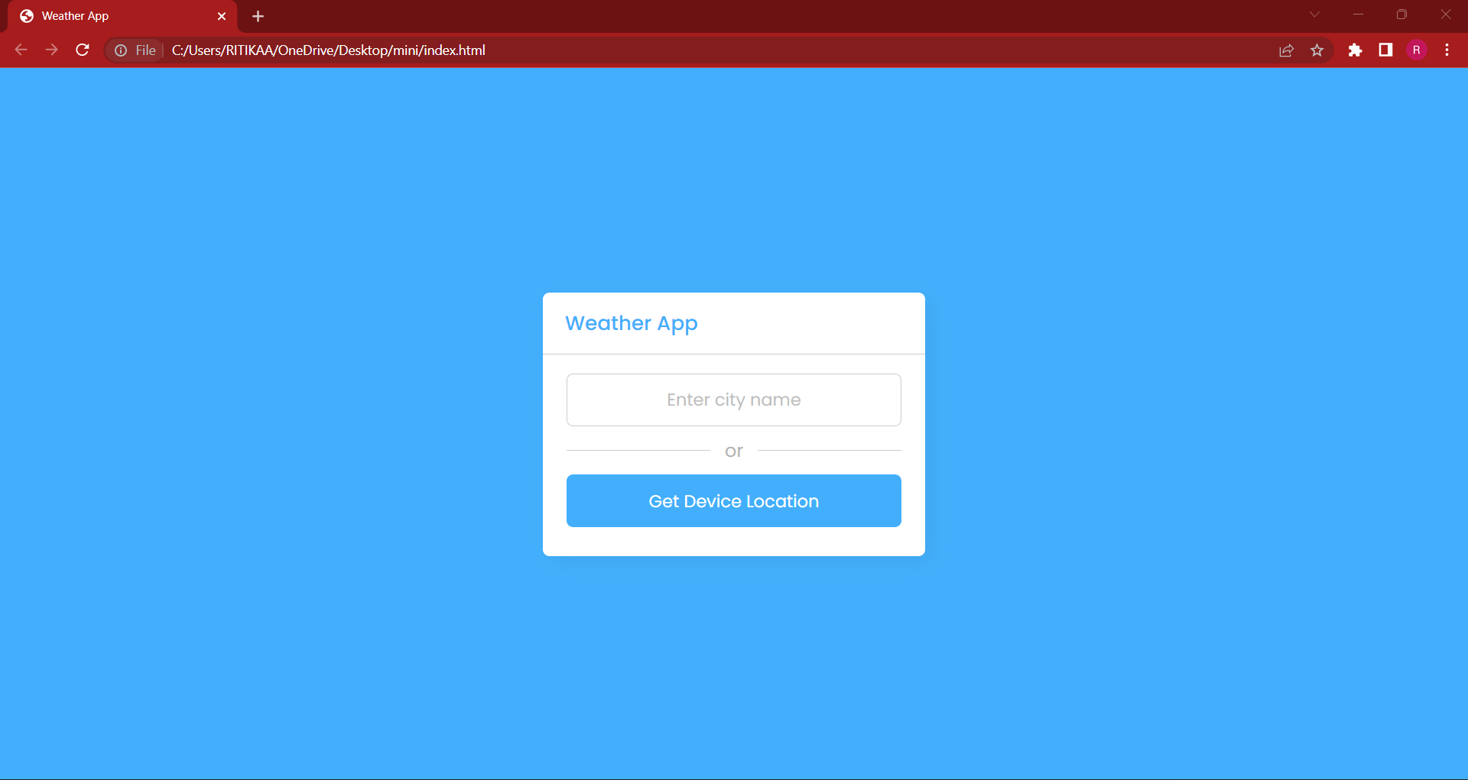
Figure (7.1) Output Screen
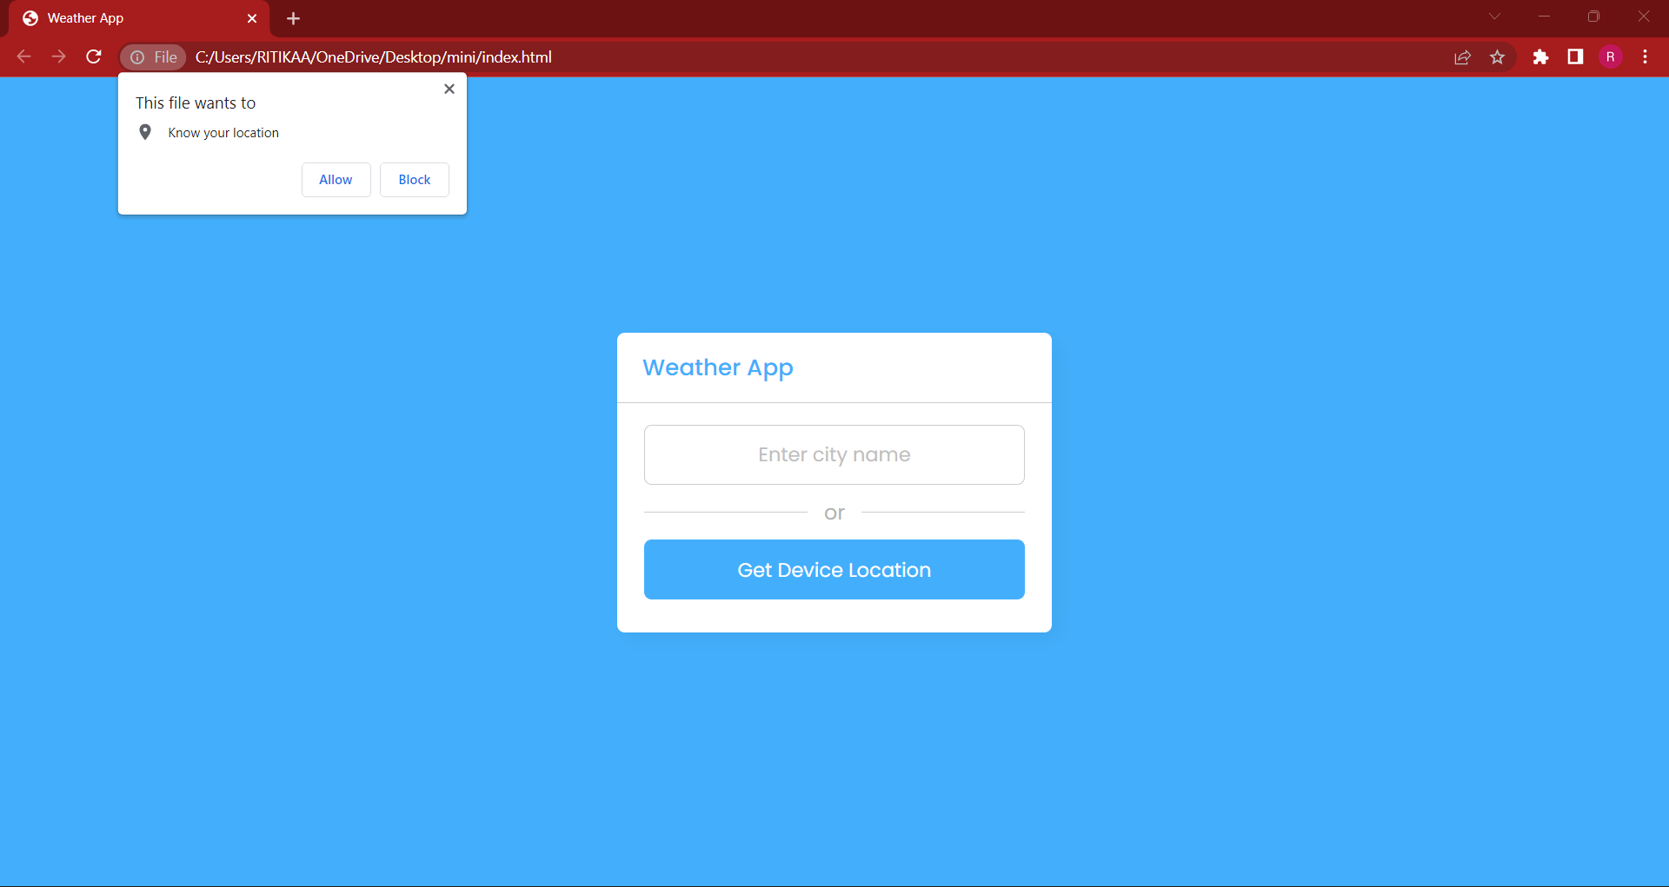
Figure (7.2) Output Screen
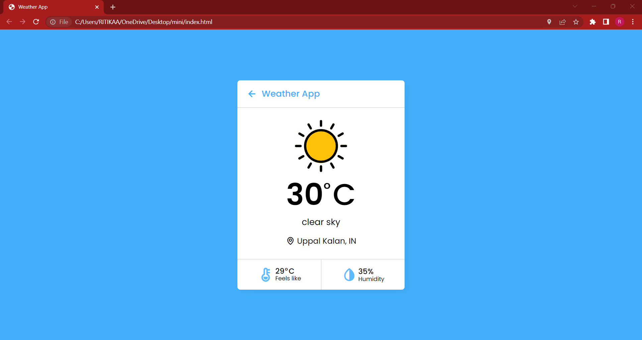
Figure (7.3) Output Screen

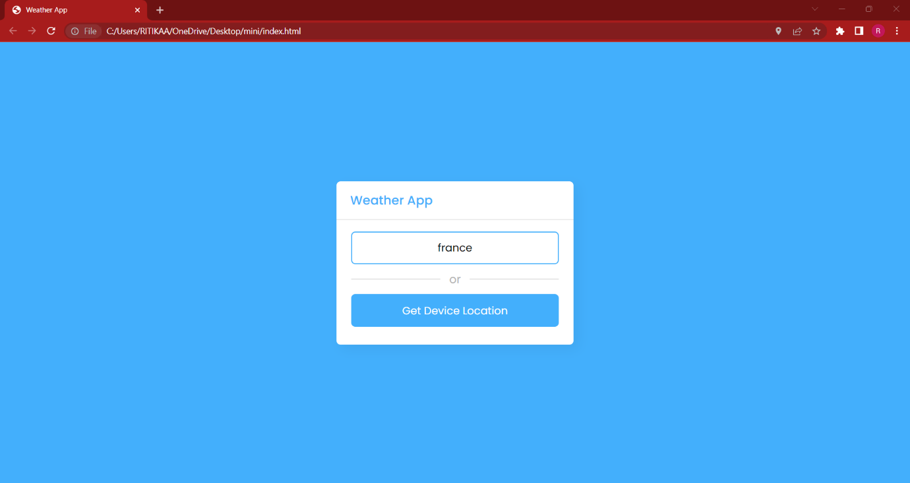
Figure (7.4) Output Screen
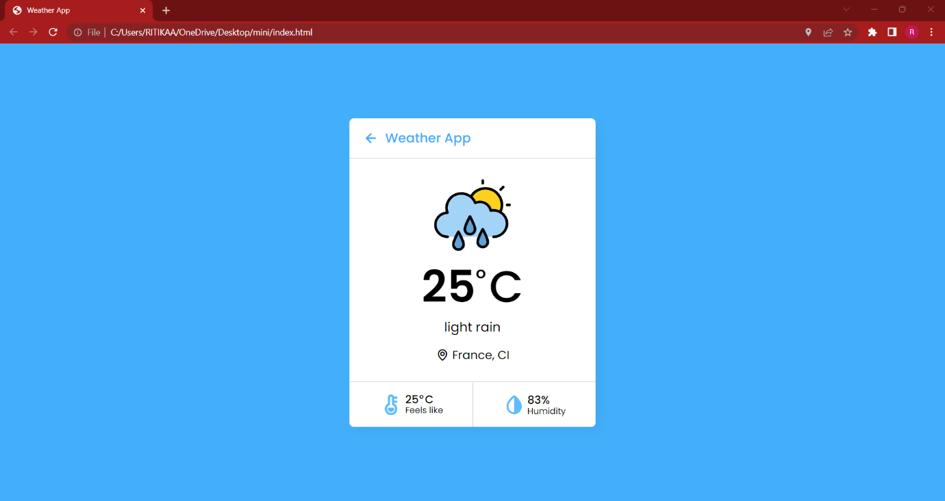
Figure (7.5) Output Screen

8. Conclusion

8.1 Conclusion

In summary, weather forecasts are increasingly accurate and useful, and their benefits extend widely across the economy. While much has been accomplished in improving weather forecasts, there remains much room for improvement. The forecasting community is working closely with multiple stakeholders to ensure that forecasts and warnings meet their specific needs. Simultaneously, they are developing new technologies and observational networks that can enhance forecaster skill and the value of their services to their users.

8.2 Future Enhancements
- The proposed system can be further optimized to provide accurate weather optics. This module can be deployed in various cloud operating systems and web applications.
- Various fields can implement our prospect to provide discussed parameters.
- Optimal features can be added for few more aspects other than weather parameters, for example: medical support, ambiance , emergencies , flood alerts and etc.,.

9. Bibliography
9.1 Websites References
- https://www.lighthouselabs.ca/en/blog/what-is-javascript-used-for#:~:text=Javascript%20is%20used%20by%20programmers,by%2097.0%25%20of%20all%20websites
- .https://www.geeksforgeeks.org/html/
- https://www.geeksforgeeks.org/css/
- https://code.visualstudio.com/docs#:~:text=Visual%20Studio%20Code%20is%20a,for%20Windows%2C%20macOS%20and%20Linux.

9.2 Technical Publication References

- Real-time assessment of fog-related crashes using airport weather data: a feasibility analysis
  - https://www.researchgate.net/publication/264629039_real-time_assessment_of_fog-related_crashes_using_airport_weather_data_a_feasibility_analysi
- Algorithmic realization of system for short-term weather forecasting
  - https://www.researchgate.net/publication/220795788_algorithmic_realization_of_system_for_short-term_weather_forecasting
- Visually comparing weather features in forecasts
  - https://www.researchgate.net/publication/282047415_visually_comparing_weather_features_in_forecasts
- A predication weather parallel with filter model based on extract event: case study is Malaysian weather for short-term
  - https://www.researchgate.net/publication/327206099_a_predication_weather_parallel_with_filter_model_based_on_extract_event_case_study_is_malaysian_weather_for_short-term
- web based weather visualization and forecasting system
  - https://www.researchgate.net/publication/321965063_web_based_weather_visualization_and_forecasting_system

10. Appendices

A. SW used
Javascript
Css
Html

B. Methodologies used
OpenWeather API
API calls
Retrieving information from cloud

C. Testing Methods used
Unit testing
Integration testing
System testing
Acceptance testing

11. Plagiarism report

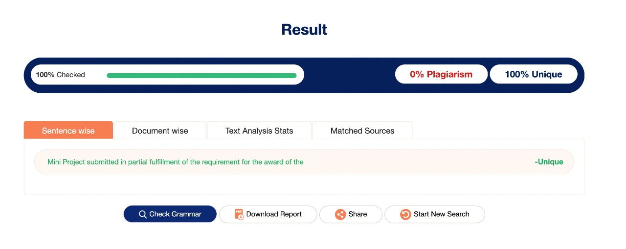
Figure (14)

